New York City- case study
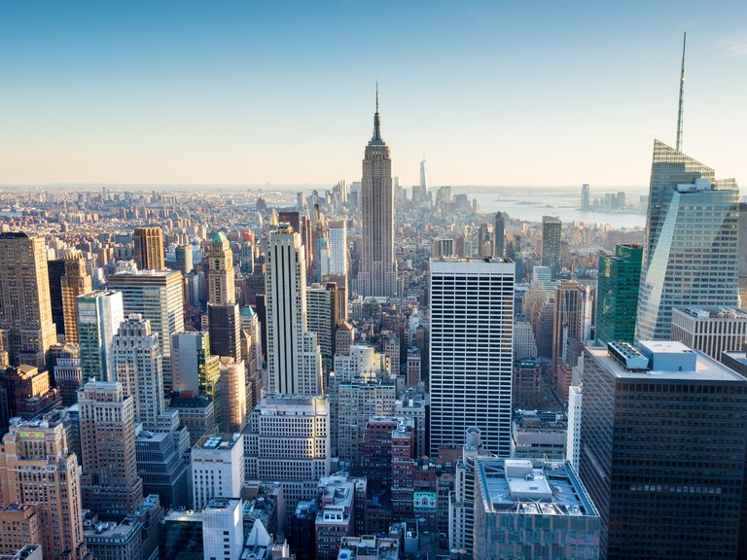
Contents page:
Page 1: Cover page
Page 2: Contents page
Page 3-8: Notes
Page:8-9: An overview of New York City.
Page: 10-14: Question 1
Page: 14-18: Question2
Page: 18-20: Question 3
Page 20-21: Question 4
Page 22: Bibliography

Notes
- Traffic congestion is when the movement of vehicles along road networks begins to slow, increasing trip times and vehicular queuing. The problem is often associated with arterial roads that become congested during peak hour periods.
- New York City’s transit system was well planned to accommodate high-density development; however, underinvestment in the last 50 years is having an impact and further increases in population will place considerable strain on the existing infrastructure.
- The central business districts of Manhattan create roughly $900 billion for the regional economy; however, the centralisation of so much employment and economic activity creates significant traffic congestion across the entire region during peak periods.
Causes and implications:
- Each weekday there are 3.6 million round trips as people travel into and out of Manhattan’s CBDs, a third of them in cars, trucks or taxis.
- Traffic moves less than 20km per hour during peak periods in virtually every street in lower Manhattan and Midtown.
- The predicted increase in NYC’s population will mean traffic congestion will continue to be a major challenge for the city and planners. If left unaddressed, by 2030 every subway line approaching Manhattan will reach capacity.
- Traffic working hours of 9am to 5pm compounds the problem of traffic congestion, as people must travel to and from work at the same time. Manhattan has a huge influx of workers every day due to the presence of so many office and retail functions.
- The population is said to increase by 1.5 million people, from 1.6 million to 3.1 million due to commuting workers. With tourists, visitors and shoppers, this island- 21.6 km long and just 3.7km at its widest- can contain 4 million people on any single day.
- In NYC, transportation is responsible for 25% of the city’s emissions. Cars, trucks, roads, and parking facilities all require space. As population This often comes at the expense of green spaces that moderate the urban heat island effect resulting from hard, non-reflective urban surfaces.
- Economically, the time spent in traffic is non-productive and costly. The economic costs of traffic in NYC are substantial, estimating to add $1.9 billion to the cost of doing business, a loss of $4.6 billion in unrealised business and $6billion in lost time and productivity.
- Cars caught in traffic consume more fuel and this adds to the cost of transporting goods and providing services. Transportation infrastructure within NYC is ageing and requires substantial investment to bring it back to a good state of repair. Traffic congestion can clearly divert important funds away from more productive forms of urban development.
- In terms of social costs, the average American now spends more than 50 minutes per day commuting and in New York City it is over an hour. People have less time to socialise, recharge and maintain their productivity. Traffic congestion can create excessive noise pollution within inner areas and it can also lead to health problems such as respiratory illnesses.
- According to the Department of Transport (DOT), New York City has some of the highest child hospitalisation rates asthma with cars and trucks accounting for 20% of emissions. Congested roads also make pedestrian activity difficult, especially for the elderly and disabled.
Concept of Sustainability
- The widely accepted definition of sustainability or sustainable development was given by World Commission o Environment and Development in 1987. It defined sustainable development as “forms of progress that meet the needs of the present without compromising the ability of future generations to meet their needs”. Sustainability requires the reconciliation, or bringing together, of social, environmental and economic adaptations or improvements whilst complying with governance demands within a society.
Planning New York City sustainably
- In 2007, the former mayor of New York Michael Bloomberg introduced a 25 year strategic planning scheme to sustainably expand the city. Titled PlaNYC, the central vision was for a ‘Greener and Greater’ New York. The plan has been internationally recognised and is seen as one of Mr Bloomberg’s greatest achievements as Mayor. The scheme focused on 127 initiatives infrastructure spending, zoning changes to 40% of the city, waterfront development, reducing GHG emissions by 16%, increasing recycling and the planting of 1 million trees across the five boroughs. The plan was participatory and consultative, involving government stakeholders from 25 agencies as well as engaging private groups. Reflective in their approach, the City continually updated and revised their goals.
Mayor Bill De Blasio’s plan
- In 2015 Mayor Bill De Blasio announced a new planning scheme titled OneNYC. The vision, ‘a strong and just city’ focuses on growth, equity, sustainability and resilience. Whilst Mr De Blasio recognised the achievements of Mr Bloomberg, he believed, a new plan was necessary to address the increasing challenges facing the city. Including some 200 new initiatives, OneNYC does build on many of the original commitments, such as reducing the city’s carbon emission by 80% by 2050. The new plan has been recognised as a comprehensive plan to reduce urban poverty within the city by increasing both the minimum wage and the number of preventative health programs.
- OneNYC directly addresses the key themes of sustainability. Socially, the plan aims to lift 800,000 New Yorkers out of poverty or near-poverty by 2025 and reduce premature mortality. Economically, the city hopes to house 4.9 million jobs within the boroughs by 2040 and reduces the annual economic losses from climate related events.
Bicycle Networks- Addressing congestion within New York City
- City planners around the world are no loner in the business of attracting and accommodating cars in city centres. Rather, they must look at alternative forms of transportation that make their cities more productive and improve liveability.
- Cities with flat topography and greater urban density are better suited to this mode of transportation.
Increasing bicycle networks
- Starting in the 1990s, the expansion of New York City’s bicycling and pedestrian infrastructure began with the Greenway Plan. Mayor Bloomberg’s transportation commissioner, Janette Sadik-Khan was instrumental in the renaissance of biking within the city.
- She began a controversial program of taking away traffic lanes from cars and giving them to cyclists and pedestrians. Since 2006, commuting numbers have doubled to around 20,000 as some 360 kilometres of new bike lanes were developed within the boroughs.

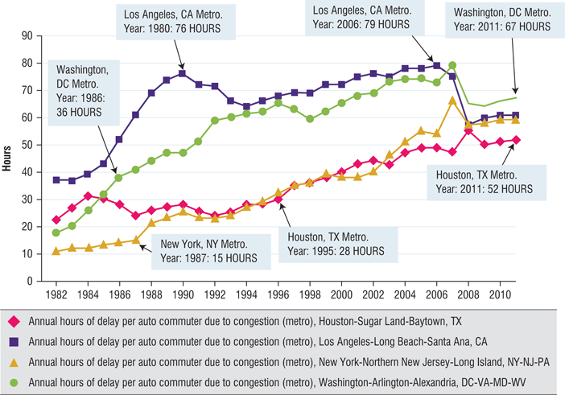
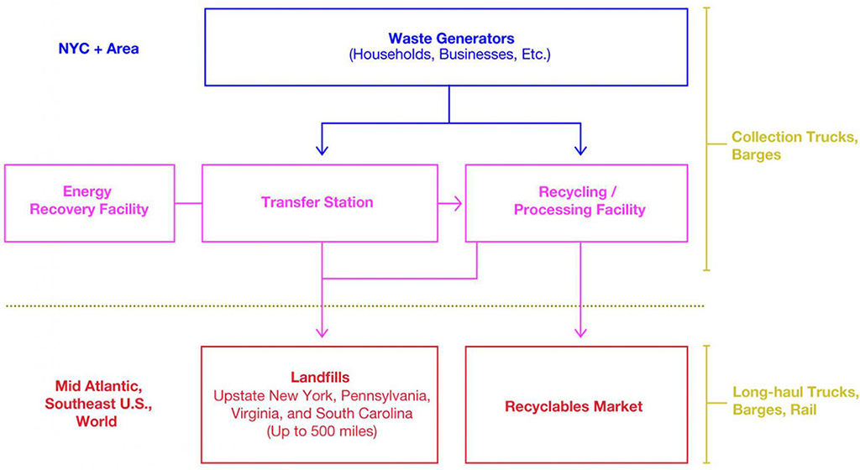
Waste management notes from handout:
Nature and scope: 1) NYC has 8.5 million residents, millions of businesses/construction projects that generate approx 14 million tons of waste and recyclables per year.
2) DSNY collects 3.8 million tons of solid waste annually. -14% is recycled and 76% to landfill-often travels long distances e.g. to Pennsylvania to Ohio, Virginia, South Carolina. In 2014, residential and commercial waste travelled to landfills up to 660 miles away- SC(South Carolina), Kentucky, Virginia, Ohio, Pennsylvania, upstate NY. -10% converted to energy at waste-to-energy facilities such as that in Newark, New jersey. -Predicted to cost the city est. $2.3 billion of city’s $75 billion annual budget.
Causes
- Affluent/consumer-minded society: buy easily and dispose waste quickly. Residents frequently eat out and dispose of containers mindlessly. NYC residents only recycle approx. 17% of total waste-half of what could be recycled under the current program. Higher standards of living results in more waste but also greater ability to invest in waste management systems.
- Each week, average New Yorker throws out nearly 15 pounds of waste at home, 9 pounds at work. Results in 3 million tons of residential waste, 3 million tons of commercial waste generated per year.
- Residents sort less than half of all materials that could be recycled-most are improperly. - Businesses also fail to recycle what they -For many years easiest and cheapest solution has been always to bury the garbage.
Implications:
- Economic: high economic impacts- spending on residential and commercial garbage is about $2.3 billion of city’s $75 billion annual budget. Private businesses pay approx $730 million annually to remove their trash. Survey by Citizen Budget Commission In NYC- $251 a tonne to collect (mot expensive in nation) compared to Washington DC who pays $182. Recycling materials cost more than other waste-approx. double. Cost $629 a tonne to collect.
Planning strategies:
1) Recycling program was attempted, but closed in 2002 because of severe budget crisis. The plan includes composting and gasification- burning waste at a very high temperature results in little exhaust. Composting=controllable microbial decompostiion of organic matter in presence of oxygen into humus (soil-like material)- can be used in veggie or flower gardens, hedges etc.
Each borough is becoming responsible for handling its own waste. Mandatory recycling began in 1989.
2)Zero Waste Plan announced in 2009 to reduce waste by 90% by 2030. The plan Is to eliminate need to send waste to out-of-state landfills.
3) PlaNYC-solid wast management became incorporated into sustainability planning. PlaNYC has the goal of reducing high amount of GHG generated by waste transportation and disposal in landfills.
Other cities:
Hong Kong: has seen waste levels grow as its economy has grown- sinc mid 1980’s solid waste load has increased by 85%. 7.2 million residents generate 6 million tonnes annually. Lack of space and high density population limited extending landfill capacity.
Initiatives: waste recycling didn’t reach policy agenda until handover in 1997-began establishing waste reduction task forces, pursuing waste reduction initiatives in different sectors of the city, since only 8% was recycled. Waste separation bins were provided in public housing to collect waste paper, aluminium cans, plastic bottles. EcoPark- reserving land for development of recycling park, providing affordable prices for local recycling industry to use over long term. Successful efforts- between 2001 and 2013, domestic recycling rate grew 10-48%.

An overview of New York City
New York City’s (NYC) metropolitan area has approximately 20 million people and was once the world’s urban agglomeration until Tokyo surpassed it in the 1950s. As the most populated city in the United States, New York is a world city that exerts significant power and influence over global activities. Despite increasing rivalry from Chinese megacities, such as Shanghai, New York City remains the world capital for commerce and finance, this can be seen in Wall Street which is famous for its large role in the international finance system.

NYC is situated in the NNE of the United States of America, 430km NE of the capital city Washington DC. NYC is located at latitude 40°42’ 52” N and longitude 74° 0’23” W.

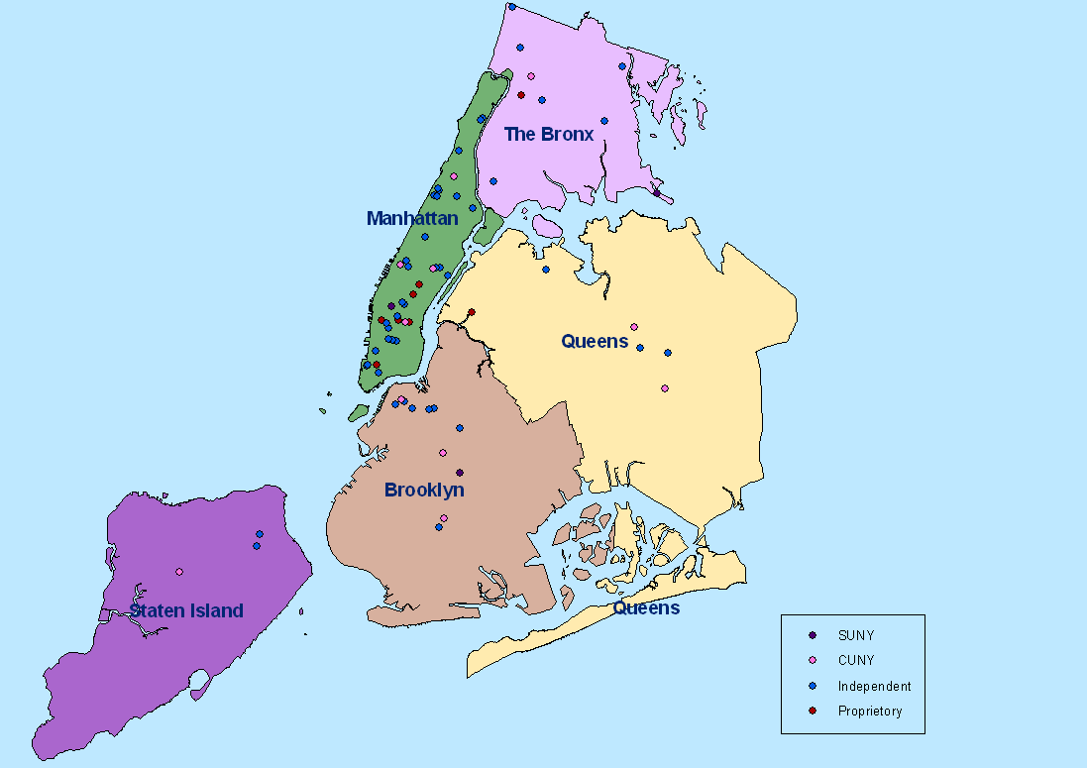
Figure 1: New York City consists of the 5 boroughs: Manhattan, Brooklyn, Staten Island,Queens and The Bronx, as shown in this image.

Figure 2: New York metropolitan area within the United States. 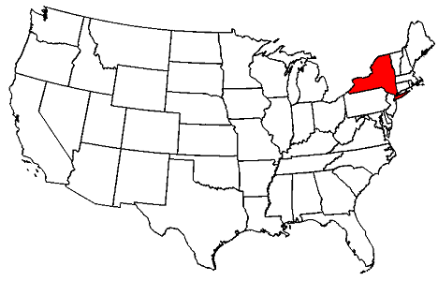

Question 1) Describe the nature,scope and causes of each of the two challenges, congestion and waste management in New York, and the implications for New York.

Traffic congestion and waste management are arguably the two biggest problems currently facing NYC. NYC was ranked 3rd on the 2017 list of the top 10 most congested cities in the world. Traffic congestion is when the movement of vehicles along road networks begins to slow, increasing trip times and vehicular queuing. The problem is often associated with arterial roads that become congested during peak hour periods. New York City’s transit system was well planned to accommodate high-density development; however, underinvestment in the last 50 years is having an impact and further increases in population will place considerable strain on the existing infrastructure.The central business districts of Manhattan create roughly $900 billion for the regional economy; however, the centralisation of so much employment and economic activity creates significant traffic congestion across the entire region during peak periods. Manhattan is a centre for employment as 26% of New Yorkers work in Manhattan.

Each weekday there are 3.6 million round trips as people travel into and out of Manhattan’s CBDs, a third of them in cars, trucks or taxis. Traffic moves less than 20km per hour during peak periods in virtually every street in lower Manhattan and Midtown. 13,000 taxis and 6000 buses add to the congestion The predicted increase in NYC’s population will mean traffic congestion will continue to be a major challenge for the city and planners. In terms of social costs, the average American now spends more than 50 minutes per day commuting and in New York City it is over an hour. People have less time to socialise, recharge and maintain their productivity. Traffic congestion can create excessive noise pollution within inner areas and it can also lead to health problems such as respiratory illnesses.
According to the Department of Transport (DOT), New York City has some of the highest child hospitalisation rates of asthma, with cars and trucks accounting for 20% of emissions. Congested roads also make pedestrian activity difficult, especially for the elderly and disabled, and can pose a problem for ambulances trying to travel patients-potentially in a life threatening situation- to hospital as quickly as possible.

If left unaddressed, by 2030 every subway line approaching Manhattan will reach capacity. Traffic working hours of 9am to 5pm compounds the problem of traffic congestion, as people must travel to and from work at the same time. Manhattan has a huge influx of workers every day due to the presence of so many office and retail functions. The population is said to increase by 1.5 million people, from 1.6 million to 3.1 million due to commuting workers. With tourists, visitors and shoppers, this island- 21.6 km long and just 3.7km at its widest- can contain 4 million people on any single day.

Figure 1: Top 10 most congested cities In the world as of 2017
2017 rank | Global city | Country | 2017 hours spent in traffic | % of total drive time in congestion
1 | Los Angeles | US | 102 | 12%
2 | Moscow | Russia | 91 | 26%
3 | New York | US | 91 | 13%
4 | Sao Paulo | Brazil | 86 | 22%
5 | San Francisco | US | 79 | 12%
6 | Bogota | Colombia | 75 | 30%
7 | London | England | 74 | 13%
8 | Atlanta | US | 70 | 10%
9 | Paris | France | 69 | 13%
10 | Miami | US | 64 | 9%
Economically, the time spent in traffic is non-productive and costly. The economic costs of traffic in NYC are substantial, estimating to add $1.9 billion to the cost of doing business, a loss of $4.6 billion in unrealised business and $6billion in lost time and productivity.Cars caught in traffic consume more fuel and this adds to the cost of transporting goods and providing services.
In terms of social costs, the average American now spends more than 50 minutes per day commuting and in New York City it is over an hour. People have less time to socialise, recharge and maintain their productivity. Traffic congestion can create excessive noise pollution within inner areas and it can also lead to health problems such as respiratory illnesses.
According to the Department of Transport (DOT), New York City has some of the highest child hospitalisation rates asthma with cars and trucks accounting for 20% of emissions. Congested roads also make pedestrian activity difficult, especially for the elderly and disabled.

Additionally, waste management is another big issue facing NYC. NYC has 8.5 million residents, millions of businesses/construction projects that generate approx 14 million tons of waste and recyclables per year. Causes include; population being an Affluent/consumer-minded society: buy easily and dispose waste quickly. Residents frequently eat out and dispose of containers mindlessly. NYC residents only recycle approx. 17% of total waste-half of what could be recycled under the current program.
Each week, average New Yorker throws out nearly 15 pounds of waste at home, 9 pounds at work. Results in 3 million tons of residential waste, 3 million tons of commercial waste generated per year.
Residents sort less than half of all materials that could be recycled-most are improperly.

Waste management consists of 2 basic stages- collection and disposal.Waste is handled by two separate systems-public and private. NYC Department of Sanitation (DSNY) collects waste from residential buildings, govt. Agencies, and non-profit organisations. Private commercial firms on the other hand don’t receive free waste removal by city govt.-they have to pay private firms to remove solid waste.

DSNY works with other corporations to manage city’s waste including: -Sims Multi Recycling Recovery Facility (Sims) -Department of Parks and Recreation (DPR) and -GreeNYC. These agencies are Involved in waste reduction, recycling, composting, and organic waste diversion.DSNY relied on landfills for garbage disposal in 1900s, but last garbage dump was closed in Dec 2001 (Fresh Kills Landfill in Staten Island). When this occurred, the City adopted 20 year plan for exporting government-managed waste; relying on truck-based system, transfer stations and deposition of it in landfills, recycling facilities and waste-to-energy plants In neighbouring states further than 750 miles. City noted that waste disposal costs would continue to increase as nearby landfills closed and trucks would have to travel further. With less places to dump it and an increasing cost of dumping it, waste is a big problem the NYC government is faced with.

The social impact of waste management is health concerns. Tourists may be deterred or put off by the city’s obvious waste problems. Trucks carrying garbage drive through low-income neighbourhoods resulting in increased air and noise pollution.

Waste management has several environmental consequences. For instance diminished air quality- in 2009 community volunteers used hand held monitors to sample air quality at three intersections with heavy traffic and they found that it increased 355% during days when truck traffic is present Mon-Sat. Finer air-borne particles (.5micron in measurement) rose over 1000% during week days. Poor air quality in North Brooklyn can be partly accounted to the kind of waste that is processed- major part is commercial debris from private corporations. Additionally Landfills are responsible for 36% of all methane emissions in the US- one of most potent contributors to global warming. Trucks use fossil fuel which contributes to release of CO2 into atmosphere.

DSNY collects 3.8 million tons of solid waste annually. 14% of this is recycled and 76% sent to landfill-often travels long distances e.g. to Pennsylvania to Ohio, Virginia, South Carolina. In 2014, residential and commercial waste travelled to landfills up to 660 miles away- SC(South Carolina), Kentucky, Virginia,and upstate NY. The other 10% is converted to energy at waste-to-energy facilities such as that in Newark, New jersey. DSNY in NYC has some of the highest collection costs compared with other American cities.
This is all predicted to cost the city a whopping estimated amount of $2.3 billion of city’s $75 billion annual budget. Private businesses pay approx $730 million annually to remove their trash. On average rubbish in NYC costs $251 a tonne to collect, which is the most expensive in the whole of USA. Additionally recycling materials cost even more to collect, approx double the cost of other waste- $629 a tonne to collect. Management of garbage will always be an issue facing every city and country in the world as it always causes some sort of pollution, however the impact it has on people and costs can be altered.

- Explain the range of planning strategies used in New York to address the two challenges, and how these compare with, and/or have been informed by, responses implemented in other world megacities.
Bicycle Networks- Addressing congestion within New York City
Many people will consider their options when commute times increase. These options may include various modes of public transit, cycling or pressuring government for change.City planners around the world are no loner in the business of attracting and accommodating cars in city centres. Rather, they must look at alternative forms of transportation that make their cities more productive and improve liveability. In some cases, this pressure is now so great that governments are looking back in time to reconsider forms of transportation that once existed before the age of mass car ownership began in the 1950s. Light rail (tram cars) and bicycling are now back in vogue as planners look to diversify the transportation options for urban commuters and reduce traffic loads.

Trying to get commuters to reconsider their car usage is essential if traffic congestion is to be addressed. An option is to charge vehicle users of arterial roads, bridges or those wishing to enter central areas. Known as congestion charging, this has been effective in London and Singapore. All of the bridges and tunnels of NYC linking the outlying boroughs to Manhattan charge tolls for each crossing made, the decision to start them in NY could’ve been prompted by their successful use in London and Singapore.

Globally, bicycling initiatives that address congestion are gaining momentum; however, they still remain areas of risk and apprehension for governments. Some cities in northern Europe have been very successful in adapting bicycling and urban design. Over half of Amsterdam’s residents use a bike on a daily basis, accounting for 38% of total traffic in the city. Similarly, in Copenhagen, 52% of residents commute by bicycle. In the United States, 70% of trips are less than 2 miles, which roughly equates to a comfortable ten minute bicycle ride.
Cities with flat topography and greater urban density are better suited to this mode of transportation.
Increasing bicycle networks: Starting in the 1990s, the expansion of New York City’s bicycling and pedestrian infrastructure began with the Greenway Plan. Mayor Bloomberg’s transportation commissioner, Janette Sadik-Khan was instrumental in the renaissance of biking within the city.
She began a controversial program of taking away traffic lanes from cars and giving them to cyclists and pedestrians. Since 2006, commuting numbers have doubled to around 20,000 as some 360 kilometres of new bike lanes were developed within the boroughs.
In 2011, the Bloomberg administration introduced a bike-sharing scheme, making 10,000 bikes available around the city. 500 bike stations are spread across 50 neighbourhoods, focusing on Manhattan, and also in Queens, Brooklyn, and New Jersey. Using a phone app or the ‘kiosk’ at any bike station and credit card, a day pass ($12-2016), 3 day pass ($24-2016) or yearly pass ($14.95/month or $155/year-2016) can be purchased. Users receive a code which they type into a keypad to release a bike.

Similar projects can be found in 165 cities wordlwide, one of the famous examples is Paris Velib. The largest program can be found in Hangzhuo, China where over 60,000 bikes are available to share. New York City’s bike sharing program has been sponsored by Citibank and MasterCard and has been a success based on rider numbers, attracting both tourists and locals alike.
In Mayor de Blasio’s OneNYC, the city will add another 320kilometres of bike lanes in the next 4 years and 10% of these will be protected. Protection comes in the form of three-lanes; a pedestrian footpath,a cycle lane followed by a lane of parked cars. The parked cars act as a barrier between the pedestrians and cyclists.
Looking into the future, sustainable urban planning that incorporates public transit; bicycling and pedestrian movement will be the most viable in terms of providing adequate amenity and functionality.

The planning strategies to address the problem of waste management are as follows:
1)The use of alternative fuel refuse trucks (powered by natural gas) has doubled as well as the number of cities in which these trucks operate has also doubled (26-57). New natural gas fleets have also come into operation in Paris, Madrid and Belgium.
2) Waste energy facilities that burn the waste and generates electricity, removing the need for landfill have come into practice. These facilities produce ash that can be used in construction which assists in keeping the air clean. Communities close by to the facilities don’t want to accept these facilities.
3) Recycling program was attempted, but closed in 2002 because of severe budget crisis. The plan includes composting and gasification- burning waste at a very high temperature,which results in little exhaust. Composting=controllable microbial decomposition of organic matter in presence of oxygen into humus (soil-like material)- can be used in veggie or flower gardens, hedges etc.
Each borough is becoming responsible for handling its own waste. Mandatory recycling began in 1989.
4)Zero Waste Plan announced in 2009 to reduce waste by 90% by 2030. The plan Is to eliminate need to send waste to out-of-state landfills.
5) PlaNYC-solid waste management became incorporated into sustainability planning. PlaNYC has the goal of reducing high amount of GHG generated by waste transportation and disposal in landfills.
Other cities:
Hong Kong: has seen waste levels grow as its economy has grown- since mid 1980’s solid waste load has increased by 85%. 7.2 million residents generate 6 million tonnes annually. Lack of space and high density population has limited extending landfill capacity.
Initiatives: waste recycling didn’t reach policy agenda until handover in 1997-began establishing waste reduction task forces, pursuing waste reduction initiatives in different sectors of the city, since only 8% was recycled. Waste separation bins were provided in public housing to collect waste paper, aluminium cans, plastic bottles. EcoPark- reserving land for development of recycling park, providing affordable prices for local recycling industry to use over long term. Successful efforts- between 2001 and 2013, domestic recycling rate grew 10-48%.
Beijing: China has experienced rapid growth, urbanisation, industrialisation resulting in a massive increase of solid waste generation.
Beijing is capital of China containing 21.15 million people and like Hong Kong faces waste management issues- waste generation exceeds capacity.
Recycling-since 1996 Beijing has attempted to practice separation at the source, promised in City’s bid for Olympics to achieve separation rate of 50% before 2008. Was achieved by 2007, with 4.7 million people contributing. In 2006, Beijing recycled 1.6 million tons of material- saved $1.4 million.
Incineration- seen as important solution to solid waste problem in Beijing, especially in waste-to-energy plants (like New York) the Government planning to build more incineration plants-between 4-10 under construction.
Problems: waste composition if often too wet to be burned- results in more coal being mixed in and therefore more GHG emissions harmful to health and environment. Public opposition has been high- has delayed many being built.
Comparisons: exporting waste In the desire to avoid potential environmental problems of treating garbage and on values that underlie NIMBY (Not In My BackYard syndrome)- keep waste reduction on political agenda in NYC, as well as HK and Beijing who value benefits of a throwaway society.
NYC political antipathy to waste- shown by local politics of waste in Staten Island- highest priority for most of Staten Island’s elected officials during 1990s was closing Fresh Kills landfill.
Hong Kong- low priority for waste management- also faces NIMBY, local residents also dislike waste incinerators.
Beijing- government placed increased emphasis on incineration as a solution-but officials are facing growing issues of local opposition- prevents plants being built.

Figure 4: Diagram showing the travel process of waste in New York.

- Explain the extent to which the planning strategies adopted in New York have been, or could be, informed by the concept of sustainability.

The widely accepted definition of sustainability or sustainable development was given by World Commission on Environment and Development in 1987. It defined sustainable development as “forms of progress that meet the needs of the present without compromising the ability of future generations to meet their needs”. Sustainability requires the reconciliation, or bringing together, of social, environmental and economic adaptations or improvements whilst complying with governance demands within a society.
In terms of sustainable urban planning, it is the development of policies and practices that aim to reduce the impacts of urban growth on society and the environment whilst achieving economic development. The complex array of demands within sustainability means that it is a conceptual vision rather than an end point.

Planning New York City sustainably
Currently urban planning within NYC centres upon sustainability. An overarching strategic plan directs a series of initiatives that align with the principles of sustainability. NYC approached sustainable planning in the aftermath of 9/11 (2001), which raised serious questions about the city’s future. The global financial crisis (GFC) in 2008 further tested the city’s administration; however they have been successful in addressing a range of urban challenges.
In 2007, the former mayor of New York Michael Bloomberg introduced a 25 year strategic planning scheme to sustainably expand the city. Titled PlaNYC, the central vision was for a ‘Greener and Greater’ New York. The plan has been internationally recognised and is seen as one of Mr Bloomberg’s greatest achievements as Mayor. The scheme focused on 127 initiatives including infrastructure spending, zoning changes to 40% of the city, waterfront development, reducing GHG emissions by 16%, increasing recycling and the planting of 1 million trees across the five boroughs. The plan was participatory and consultative, involving government stakeholders from 25 agencies as well as engaging private groups. Reflective in their approach, the City continually updated and revised their goals.
Mayor Bill De Blasio’s plan
In 2015 Mayor Bill De Blasio announced a new planning scheme titled OneNYC. The vision, ‘a strong and just city’ focuses on growth, equity, sustainability and resilience. Whilst Mr De Blasio recognised the achievements of previous mayor Mr Bloomberg’s policies, he believed, a new plan was necessary to address the increasing challenges facing the city. Including some 200 new initiatives, OneNYC does build on many of the original commitments, such as reducing the city’s carbon emissions by 80% by 2050. The new plan has been recognised as a comprehensive plan to reduce urban poverty within the city by increasing both the minimum wage and the number of preventative health programs.
OneNYC attempts to address a number of challenges, including a rapidly growing population, rising inequality, aging infrastructure and climate change. Hurricane Sandy in 2012 crippled New York City’s economy as well as causing death and destruction. The flooding of the subway system and road tunnels isolated the Financial District and shut down the New York Stock Exchange for two days.
The natural disaster put the issue of climate change at the forefront of public policy. OneNYC includes initiatives to make the city more resilient in the face of predicted rises in sea levels and increased storm activity. This follows extensive development along the city’s waterfront such as that could now be at risk as can be seen.
OneNYC directly addresses the key themes of sustainability. Socially, the plan aims to lift 800,000 New Yorkers out of poverty or near-poverty by 2025 and reduce premature mortality. Economically, the city hopes to house 4.9 million jobs within the boroughs by 2040 and reduces the annual economic losses from climate related events.
Environmentally, an ongoing goal is to have the best air quality of any US city and sending zero waste to landfill. During the creation of the plan Mayor de Blasio and city officials consulted stakeholder groups including residents, advocacy groups, elected officials and business leaders in roundtable discussions.
A political aim is to ensure that all New Yorkers will have access to resources that promote civic engagement through providing high-quality, conveniently located, community-based City resources.

Question 4) Discuss the extent to which these strategies have enhanced the sustainability and the liveability of New York.

Addressing sustainability and liveability- bicycling networks
Social benefits: bicycling within New York has increased three fold since 2000; conversely the risk of injury has declined considerably. The health benefits are significant, increasing fitness levels means cyclists are less likely to rely on the heavily subsidised health systems. This is pivotal in helping the American population to get healthier, as in 2010 32.2% of men and 35.5% women were classified as being obese. Obesity can lead to life threatening diseases such as heart disease, diabetes and several types of cancer. Bicycling is accessible to all socio economic groups and unlike congestion charging it does not discriminate against the poor. Avoiding traffic congestion makes people less stressed.
Economic benefits: The public cost of bicycling infrastructure is minimal when compared to other forms of transportation. New York City’s bus and subway systems are heavily subsidised. The cost of building a kilometre of freeway can equate to hundreds of kilometres of bike paths, which take far less time to construct. Indirect economic benefits can be gained from reduced traffic congestion and green infrastructure can add to the appeal of areas, lifting real estate values. Much of the money spent on cars goes offshore and is not circulated through the local economy.
Environmental benefits: A cyclist takes up far less road space than a car, consequently other urban land uses and functions can be accommodated for, including open spaces and housing. Moreover, less on-street parking is required and the activity does not contribute to climate change through vehicle emissions.

Reducing amount of cars on the road is a sustainable practice as it reduces New York’s CO2 emission rate as well as reducing the emission of harmful particulate matter from cars, which will result in less global warming occurring, less pollution and less bad health side effects from particulate matter from cars. Transportation on road networks is responsible for 25% of New York’s GHG emissions, therefore lowering need to use transport on the road network will lower this as bicycles don’t emit any emissions. If there are less cars on the road this means the need to expand road networks is reduced. This also potentially means that there is more room for green spaces which are good for the environment, as road networks don’t have to expand and encroach on other land uses. Footpaths for cycling additionally take up less room than roads which saves space and money.

Bibliography

Text Book: WA ATAR Geography Units 3 and 4 (second edition) Geographical Association of Western Australia. Editors: Anna Griffin, Darryl Michie and Tracy Smith.

Traffic congestion and waste management- hand out.

https://www.dec.ny.gov/chemical/292.html

https://www.theguardian.com/sustainable-business/new-york-waste-management-plans-conflict

https://macaulay.cuny.edu/eportfolios/macbride13/research/a-timeline-of-solid-waste-management-in-new-york-city/

https://ny.curbed.com/2018/2/6/16979696/new-york-city-traffic-congestion-second-worst

http://www.herculture.org/blog/2016/5/6/the-effects-of-and-solutions-to-traffic-congestion-in-nyc

https://www.tomtom.com/en_gb/trafficindex/city/new-york

http://ontheworldmap.com/usa/city/new-york-city/

